Algorithms and Programming I
LAB 9

Exercises

1- Write a function that determines a number (between 1000 and 9999) can be divided into the sum of its digits or not.

Write another function that finds a number is a deu number or not (by calling the other function many times).


A deu number produces another number which can also be divided into the sum of its digits.

Examples:
Input: 8748 Input: 2916 Input: 1458
Output: true Output: true Output: true

8748 / 27 = 324 2916 / 18 = 162 1458 / 18 = 81
324 / 9 = 36 162 / 9 = 18 81 / 9 = 9
36 / 9 = 4 18 / 9 = 2

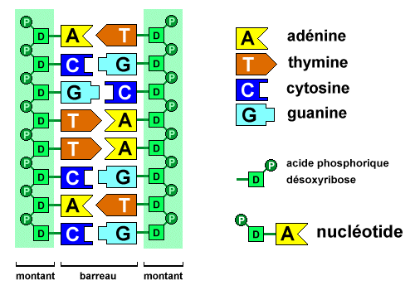
2- Write a procedure that prints the complement of given DNA sequence.

The complement of a DNA sequence is the sequence written backwards exchanging all A's for T's, all T's for A's, all G's for C's and all C's for G's.

Example:
complementDNA(“AGTAAAC”)
Output: TCATTTG

3- The following Fibonacci sequence is said to be of order 2.

f₀ = 0

f₁ = 1
f_{n} = f_{n-1} + f_{n-2} for n ≥ 2

In general, a Fibonacci sequence of order k can be defined as follows:

f_{n} = 0 for 0 ≤ n ≤ k-2
f_{k-1} = 1
f_{n} = f_{n-1} + f_{n-2} + ... + f_{n-k} for n ≥ k

Write a function that computes the n^{th} Fibonacci number of a Fibonacci sequence of order k.

Examples:
Inputs: n=8
k=2
Output: The 8th Fibonacci Number of Order 2 = 21

Inputs: n=13
k=5
Output: The 13th Fibonacci Number of Order 5 = 236

Inputs: n=22
k=7
Output: The 22th Fibonacci Number of Order 7 = 31489

4- Write a function that finds the factorial of a number.

Write a function that finds Binomial Coefficient of two numbers: n and k. This function should call factorial function three times.

Write a function that finds the result of the following formula. This function should call binomial coefficient function many times. .
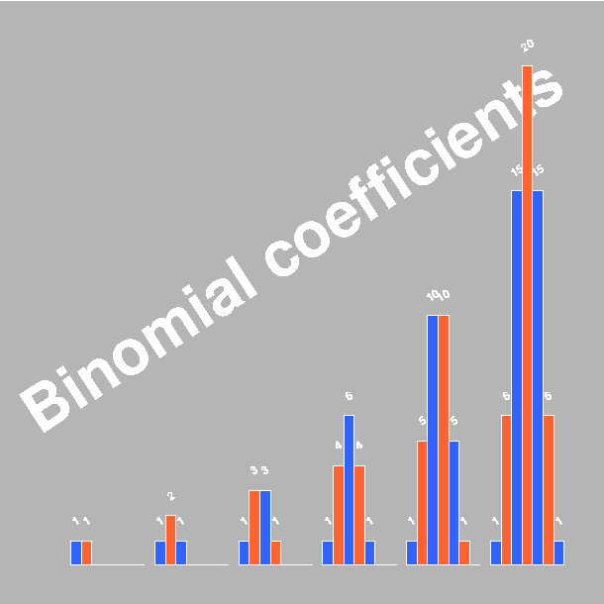
The factorial of n is:

The Binomial Coefficient is
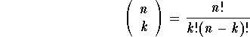
Formula:
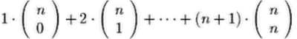

5- Write a function (ToUp) that takes a string and changes all letters to upper case and return the result string.

Don’t use C# ToUpper() function.

Example:
Input String: "FuncTIon"
Output Strings: "FUNCTION"

